Introduction for Writing and Submit Journal Articles at sintuwumarosoJET (Center, Bold, 16pt)

**First Author1, Second Author2, Third Author3 (10 pt)**

1Univesitas Sintuwu Maroso, Poso, Indonesia (8 pt)

2Universitas Sintuwu Maroso, Poso, Indonesia

3Universitas Sintuwu Maroso, Poso, Indonesia

***Corresponding Author***[*emailutama@unsimar.ac.id*](mailto:emailutama@unsimar.ac.id)

**Abstract (9 pt):** An abstract is often presented separate from the article, so it must be able to stand alone. A well-prepared abstract enables the reader to identify the basic content of a document quickly and accurately, to determine its relevance to their interests, and thus to decide whether to read the document in its entirety. The abstract should be informative and completely self-explanatory, provide a clear statement of the problem, the proposed approach or solution, and point out major findings and conclusions. **The Abstract should be 100 to 250 words in length.** References should be avoided, but if essential, then cite the author(s) and year(s). Standard nomenclature should be used, and non-standard or uncommon abbreviations should be avoided, but if essential they must be defined at their first mention in the abstract itself. No literature should be cited. The keyword list provides the opportunity to add 3 to 5 keywords, used by the indexing and abstracting services, in addition to those already present in the title (9 pt).

**Keywords:** *firt keyword; second keyword; third keyword;*

1. **INTRODUCTION (10 PT)**

The main text format consists of a flat left-right columns on A4 paper (quarto). The margin text from the left and top are 2.5 cm, right and bottom are 2 cm. The manuscript is written in Microsoft Word, single space, Time New Roman 10 pt, and maximum 12 pages for original research article, or maximum 16 pages for review/survey paper.

A title of article should be the fewest possible words that accurately describe the content of the paper. The title should be succinct and informative and no more than about 12 words in length. Do not use acronyms or abbreviations in your title and do not mention the method you used, unless your paper reports on the development of a new method. Titles are often used in information-retrieval systems. Avoid writing long formulas with subscripts in the title. Omit all waste words such as "*A study of ...*", "*Investigations of ...*", "*Implementation of ...*”, "*Observations on ...*", "*Effect of.....*", “*Analysis of …*”, “Design of…”, etc.

A concise and factual abstract is required. The abstract should state briefly the purpose of the research, the principal results and major conclusions. An abstract is often presented separately from the article, so it must be able to stand alone. For this reason, References should be avoided, but if essential, then cite the author(s) and year(s). Also, non-standard or uncommon abbreviations should be avoided, but if essential they must be defined at their first mention in the abstract itself. Immediately after the abstract, provide a maximum of 7 keywords, using American spelling and avoiding general and plural terms and multiple concepts (avoid, for example, 'and', 'of'). Be sparing with abbreviations: only abbreviations firmly established in the field may be eligible. These keywords will be used for indexing purposes.

Indexing and abstracting services depend on the accuracy of the title, extracting from it keywords useful in cross-referencing and computer searching. An improperly titled paper may never reach the audience for which it was intended, so be specific.

1. **METHOD (10 PT)**

Explaining research chronological, including research design, research procedure (in the form of algorithms, Pseudocode or other), how to test and data acquisition. The description of the course of research should be supported references, so the explanation can be accepted scientifically, Figures 1-2 and Table 1 are presented center, as shown below and cited in the manuscript. Figure 2(a) shown math representation ability students and Figure 2(b) reasoning ability students.

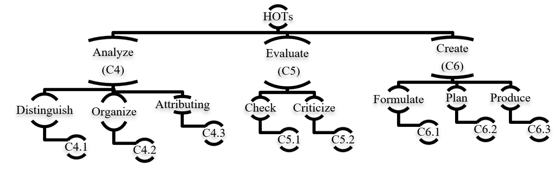

Figure 1. Cognitive process dimension

|  |  |
| --- | --- |
|  |  |
| (a) | (b) |
| Figure 2. Pretest, posttest, and N-gain for (a) math representation ability students and (b) reasoning ability students | |

Table 1. Internal consistency reliability of biology test

|  |  |  |
| --- | --- | --- |
| SN | Indicator | Value |
| 1 | Number of Item | 60 |
| 2 | Kuder Richardson (KR-20) | 0.620 |
| 3 | Cronbach's Alpha Based on Standardized Items | 0.617 |
| 4 | Mean Item Difficulty | 0.56 |
| 5 | Mean Item Difficulty | 0.4 |

1. **RESULTS AND DISCUSSION (10 PT)**

In this section, it is explained the results of research and at the same time is given   
the comprehensive discussion. Results can be presented in figures, graphs, tables and others that make   
the reader understand easily. The discussion can be made in several sub-sections.

**3.1. Sub section 1**

Equations should be placed at the center of the line and provided consecutively with equation numbers in parentheses flushed to the right margin, as in (1). The use of Microsoft Equation Editor or MathType is preferred.

$E_{v}-E=\frac{h}{2.m} (k_{x}^{2}+k_{y}^{2}$) (1)

All symbols that have been used in the equations should be defined in the following text.

**3.2. Sub section 2**

Proper citation of other works should be made to avoid plagiarism. When referring to a reference item, please use the reference number as in or for multiple references. The use of ”Ref...” should be employed forany reference citation at the beginning of sentence. For any reference with more than 3 or more authors, only the first author is to be written followed by *et al*. (e.g. in ). Examples of reference items of different categories shown in the References section. Each item in the references section should be typed using 8 pt font size.

3.2.1. Subsub section 1

yy

3.2.2. Subsub section 2

zz

1. **CONCLUSION (10 PT)**

Provide a statement that what is expected, as stated in the "INTRODUCTION" section can ultimately result in "RESULTS AND DISCUSSION" section, so there is compatibility. Moreover, it can also be added the prospect of the development of research results and application prospects of further studies into the next (based on result and discussion).

**ACKNOWLEDGEMENTS (10 PT)** (Optional)

Give credit to funding bodies and departments that have been of help during the project, for instance by supporting it financially.

**APPENDICES (10 PT)** (Optional)If there is more than one appendix, they should be identified as Appendix I, Appendix II, etc.

**REFERENCES (10 PT)**

All references should be to the most pertinent, up-to-date sources **and the minimum of references** are **8 entries** (for original research paper)and **10 entries** (for review/survey paper). References are written in **APA style**. Use **Mendeley** tool for reference management and formatting, and choose **APA style**. Please use a consistent format for references-see examples (8 pt):

*See example :*

**REFERENCES**

Akmal, S. (2011, March 13). Nasib Bahsa Aceh di tengah euforia nasionalisme Keacehan. *Serambi Indonesia*, p. Opini column. (newspaper in print)

Al-Auwal, T. M. R. (2013, September 16). Tradisi ‘Meuramien’ pada Musim Semi [‘Meuramien’ tradition in Spring]. *Serambinews.com.* Retrieved from <http://aceh.tribunnews.com/2013/09/16/tradisi-meuramien-pada-musim-semi> (newspaper online)

Azwardi. (2018). *Metode penelitian pendidikan bahasa dan sastra Indonesia* [Research methods in Indonesian language education and literature]. Banda Aceh: Syiah Kuala Universiti Press. (title of books in other languages must be translated into English)

Harun, M., & Aini, H. (2016). Code Mixing of Chinese with Indonesian by Junior High Student. *Proceedings of the 1st English Education International Conference (EEIC): Current Trends in Language and Education*. 12-13 November 2016, Syiah Kuala University, Banda Aceh. (conference proceedings)

Pillai, S. (2015). Rhoticity in Malaysian English: The emergence of a new norm? In U. Gut, R. Fuchs & E. M. Wunder (Eds.), *Universal or diverse paths to English linguistics* (pp. 23-40)*.* Berlin: Mouton de Gruyter. (book chapter)

Ramli. (2014). *Karakter masyarakat Aceh dalam novel Lampuki* [The characters of the Acehnese in the novel *Lampuki*]. *Pesona Dasar*, 1(2), 40-47. (titles published in journals not in English must be translated into English)

Sakadolskis, E. A. (2003). The use of figurative language in the construction of musical meaning: A case study of three sixth grade General Music classes (Doctoral dissertation). University of Maryland, College Park. (thesis)

Yusuf, Y. Q., Pillai, S., & Mohd. Ali, N.T.A. (2013). Speaking Acehnese in Malaysia. *Language and Communication, 33*(1), 50-60. (journal)

**ABOUT THE AUTHORS (10 PT)**

**First Author** is is a lecturer at English Education Department of Sintuwu Maroso University, Poso. She graduated from Tadulako University and her interests are in speaking, reading literacy, and English for specific purposes. She can be contacted at [journalofenglishteaching@unsimar.ac.id](mailto:journalofenglishteaching@unsimar.ac.id)

**Second Author** is is a lecturer at English Education Department of Sintuwu Maroso University, Poso. She graduated from Tadulako University and her interests are in speaking, reading literacy, and English for specific purposes. She can be contacted at [journalofenglishteaching@unsimar.ac.id](mailto:she.poai@unsimar.ac.id)